**1. Researching Built-In Datasets**

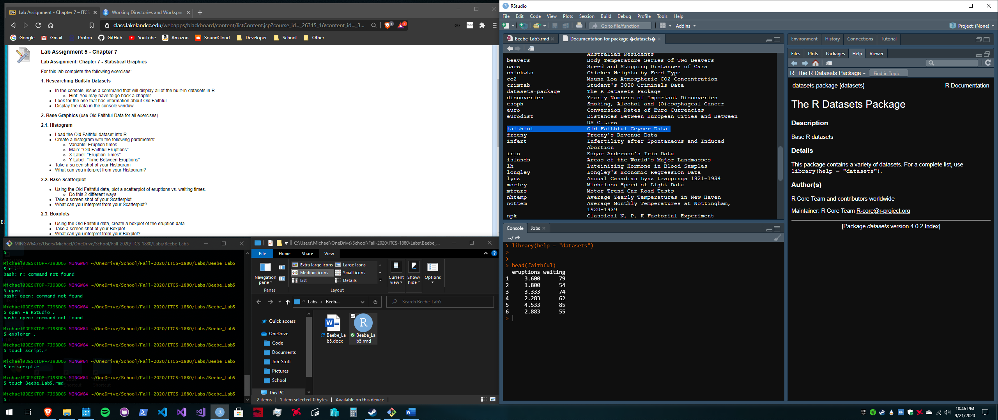

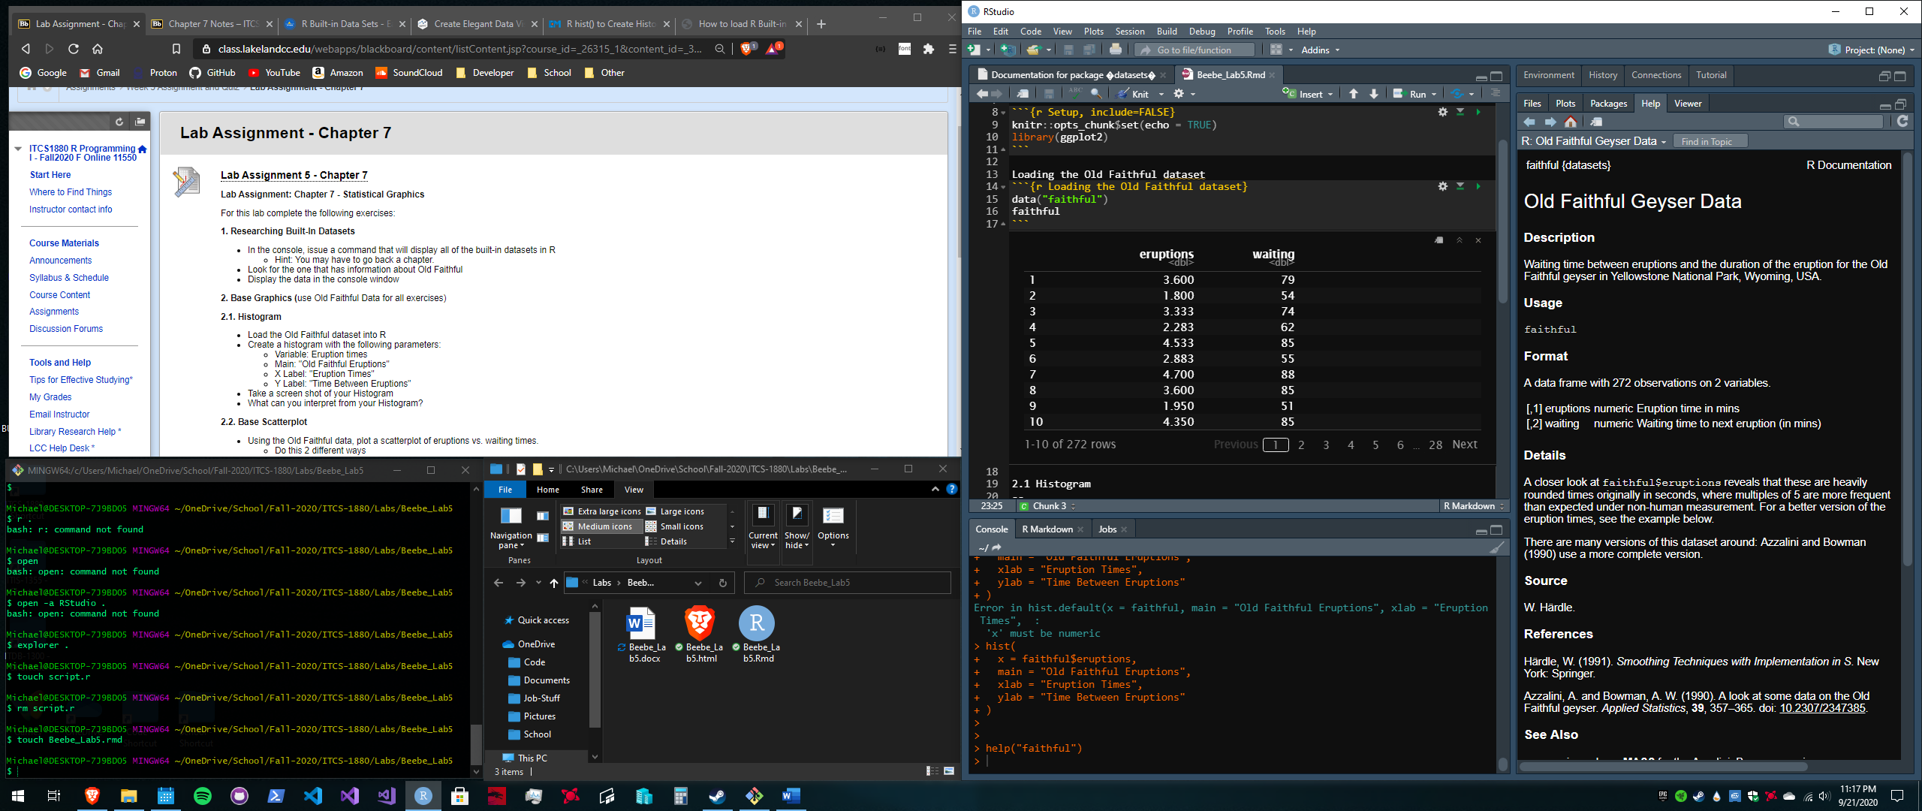

**2.1 Histogram**

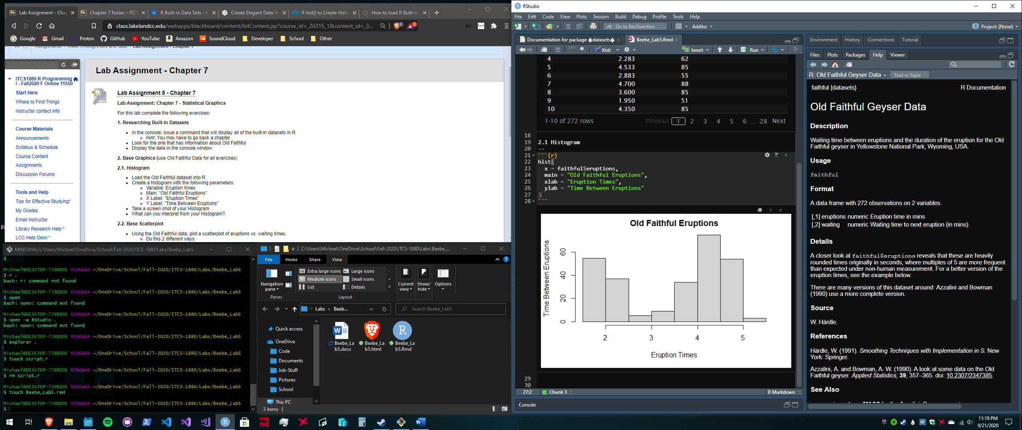

**2.2 Base Scatterplot**

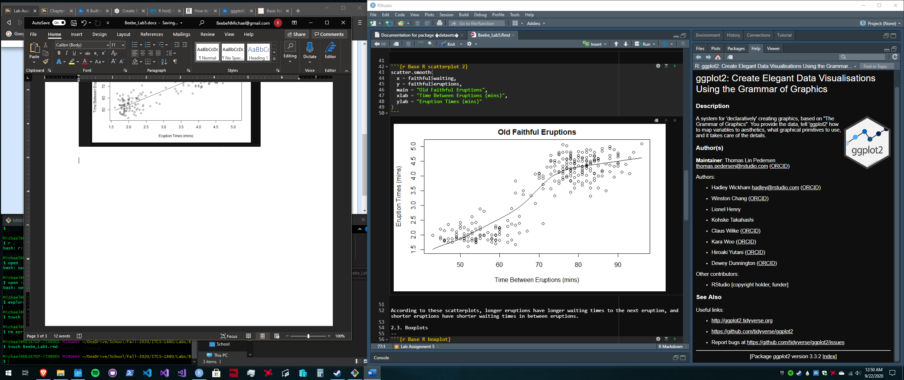

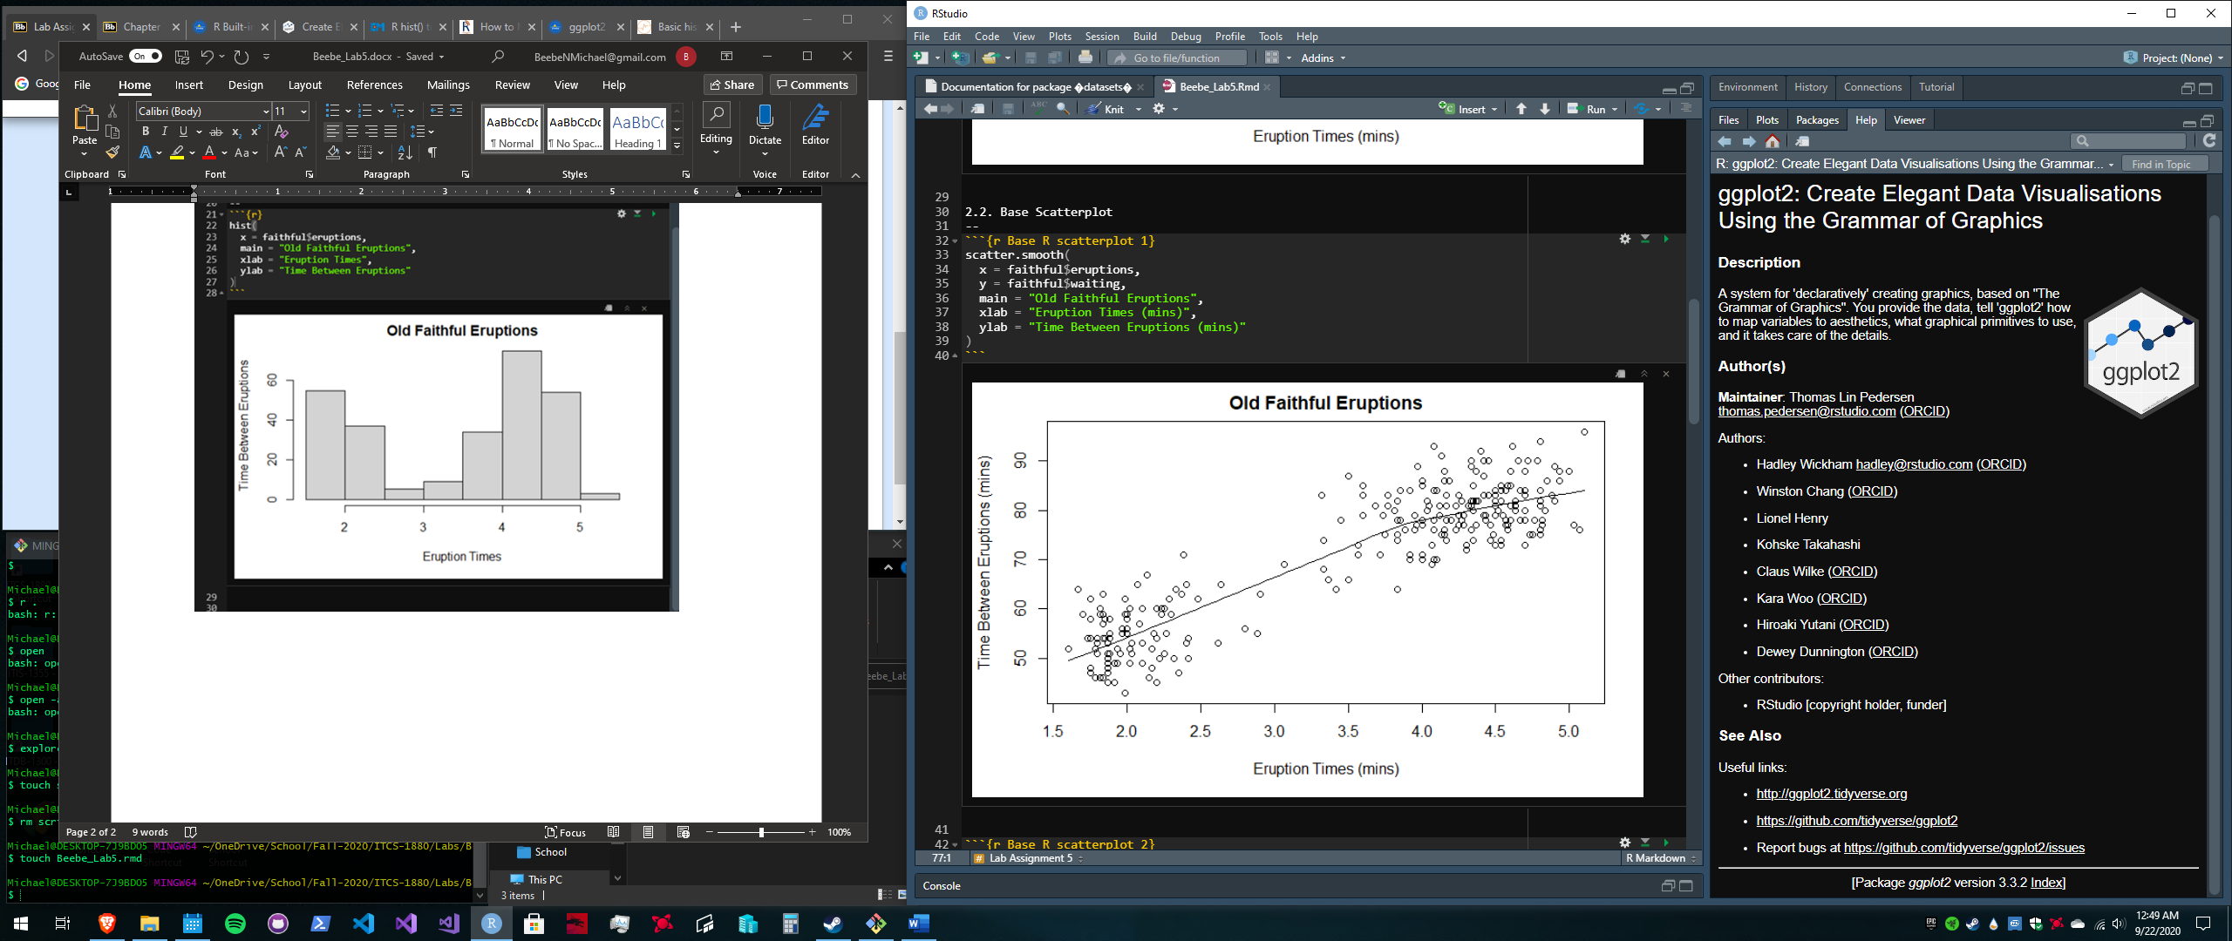

According to these scatterplots, longer eruptions have longer waiting times to the next eruption, and shorter eruptions have shorter waiting times in between eruptions.

**2.3. Boxplots**

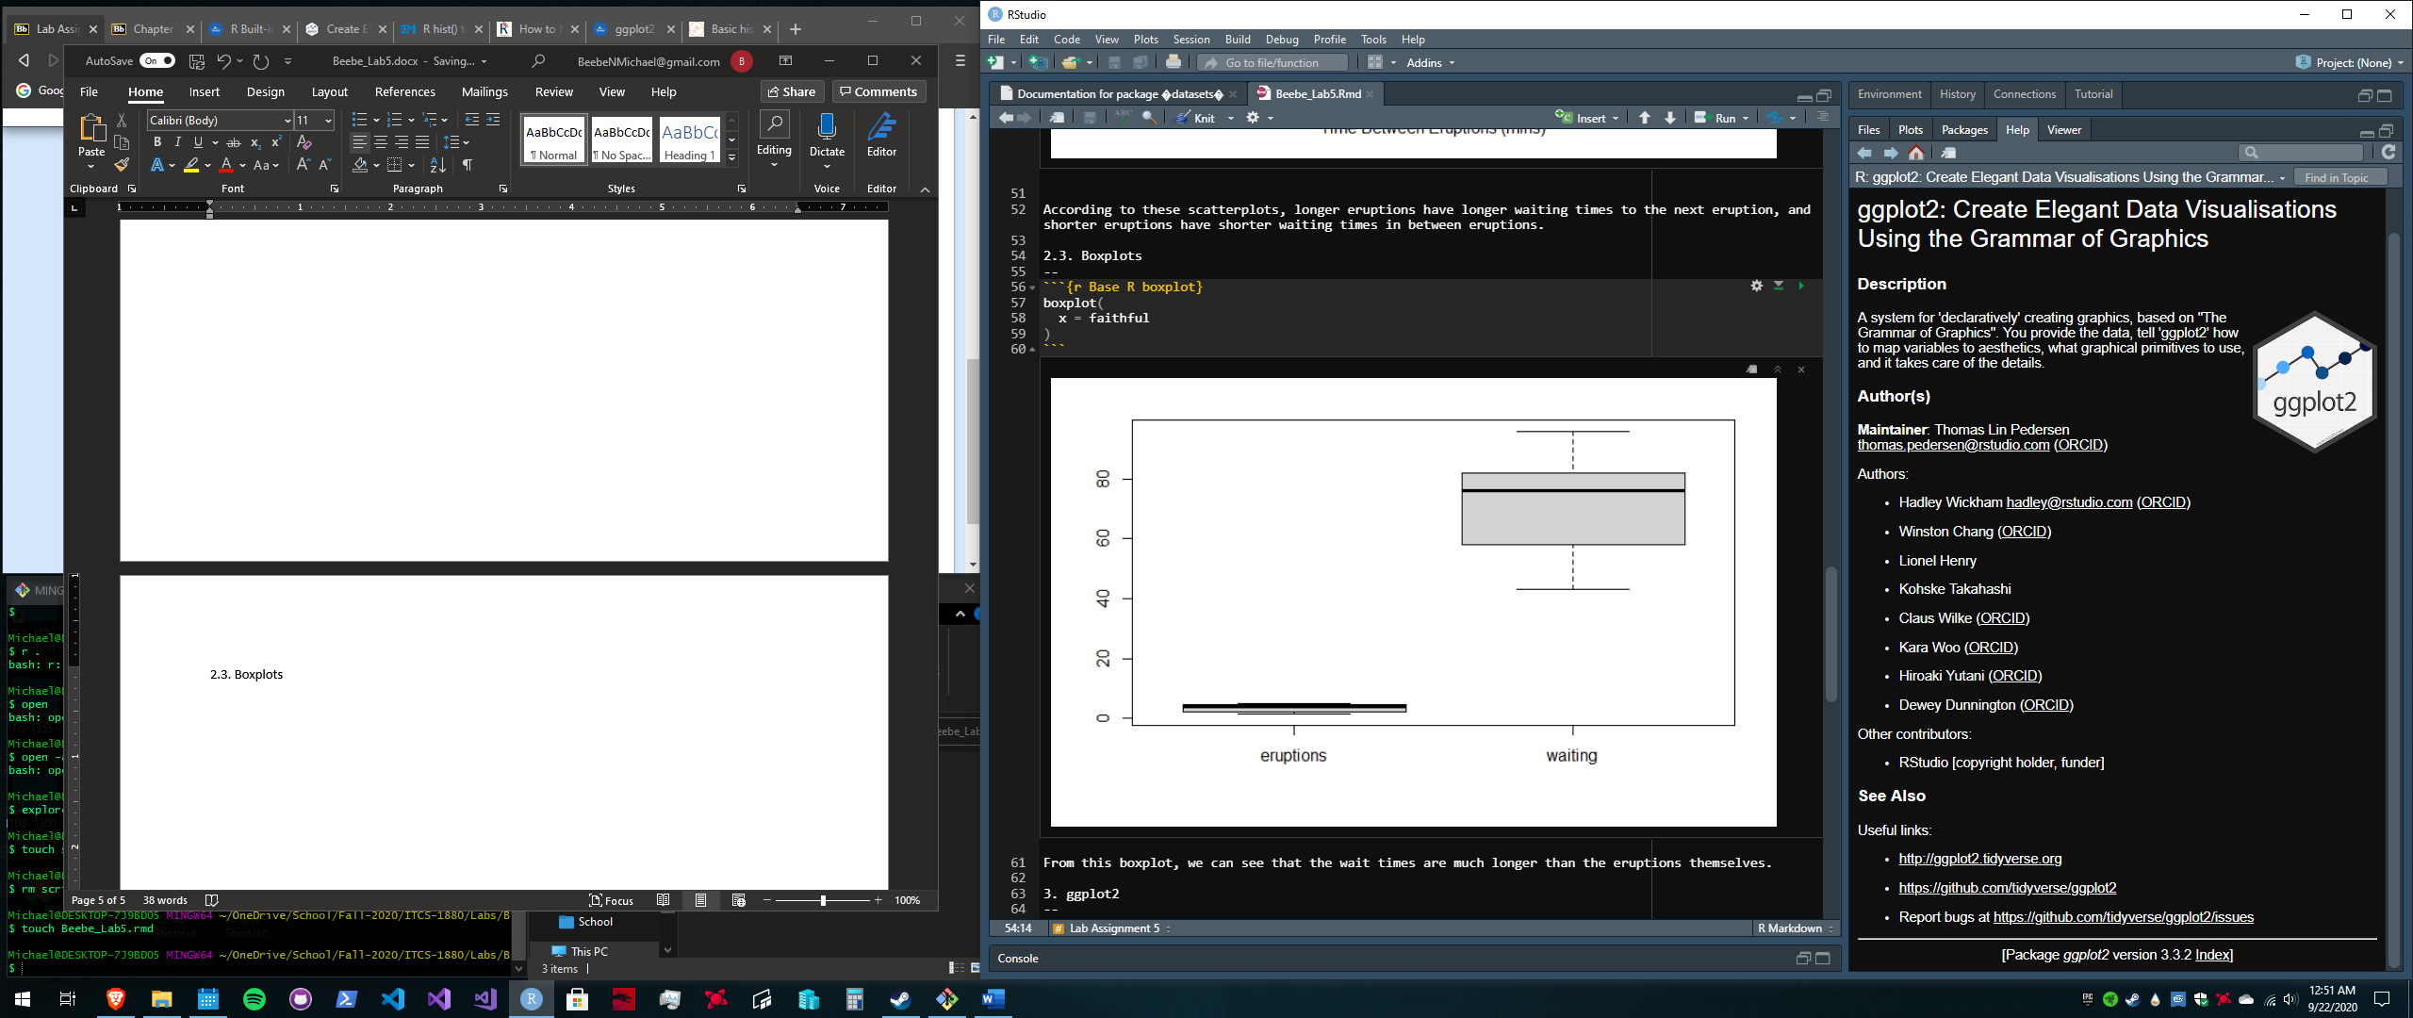

From this boxplot, we can see that the wait times are much longer than the eruptions themselves.

**3.1 Histograms and Densities**

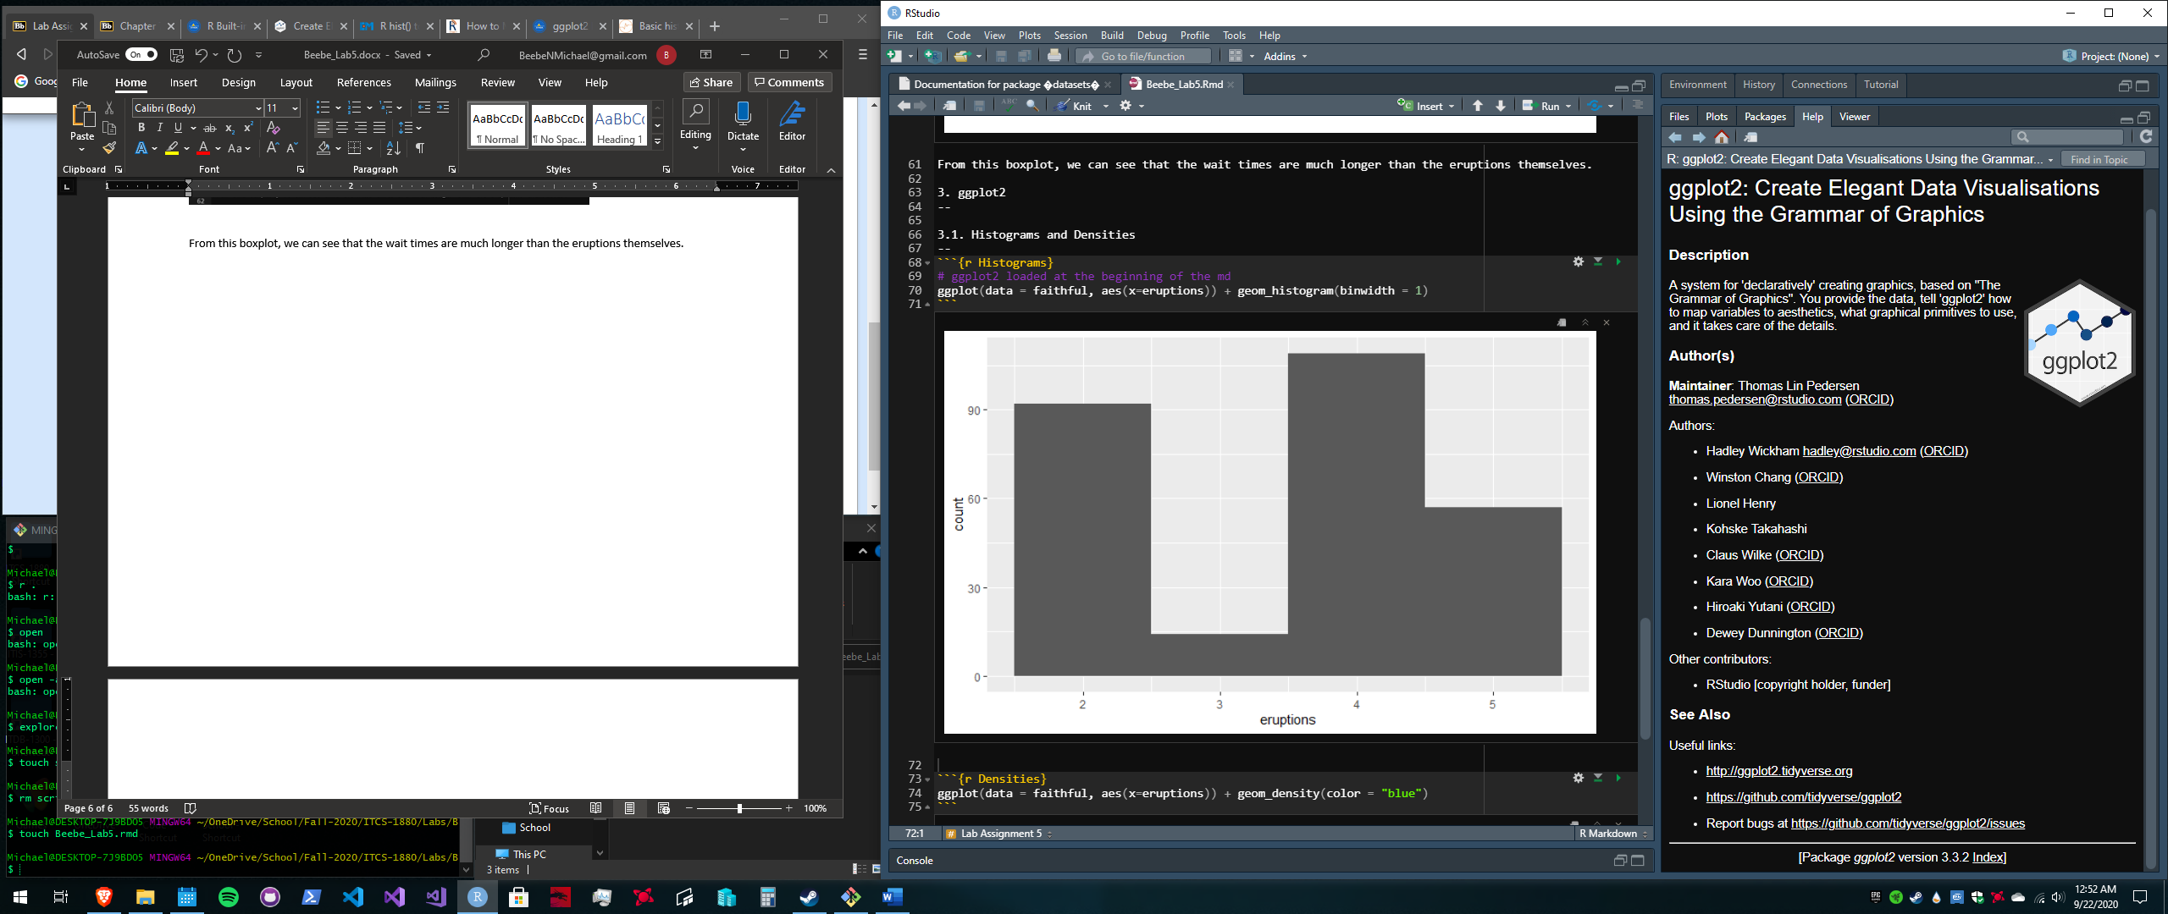

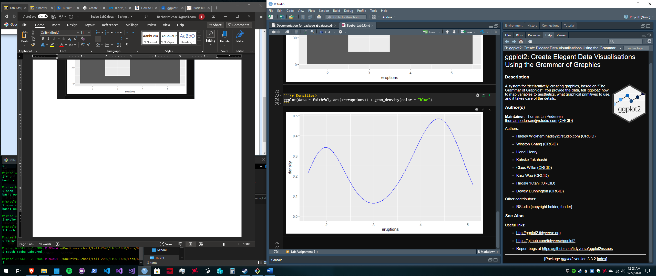

**3.2 Scatterplots**

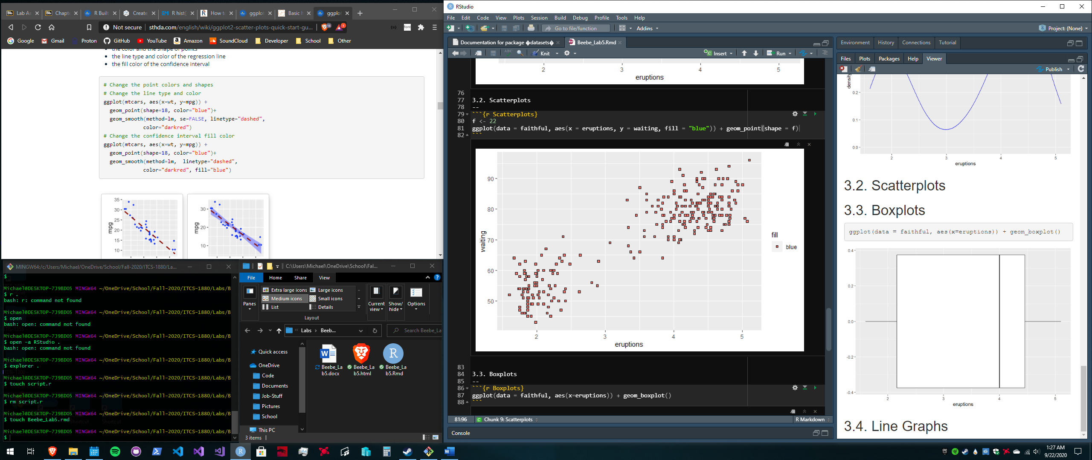

**3.3 Boxplots**

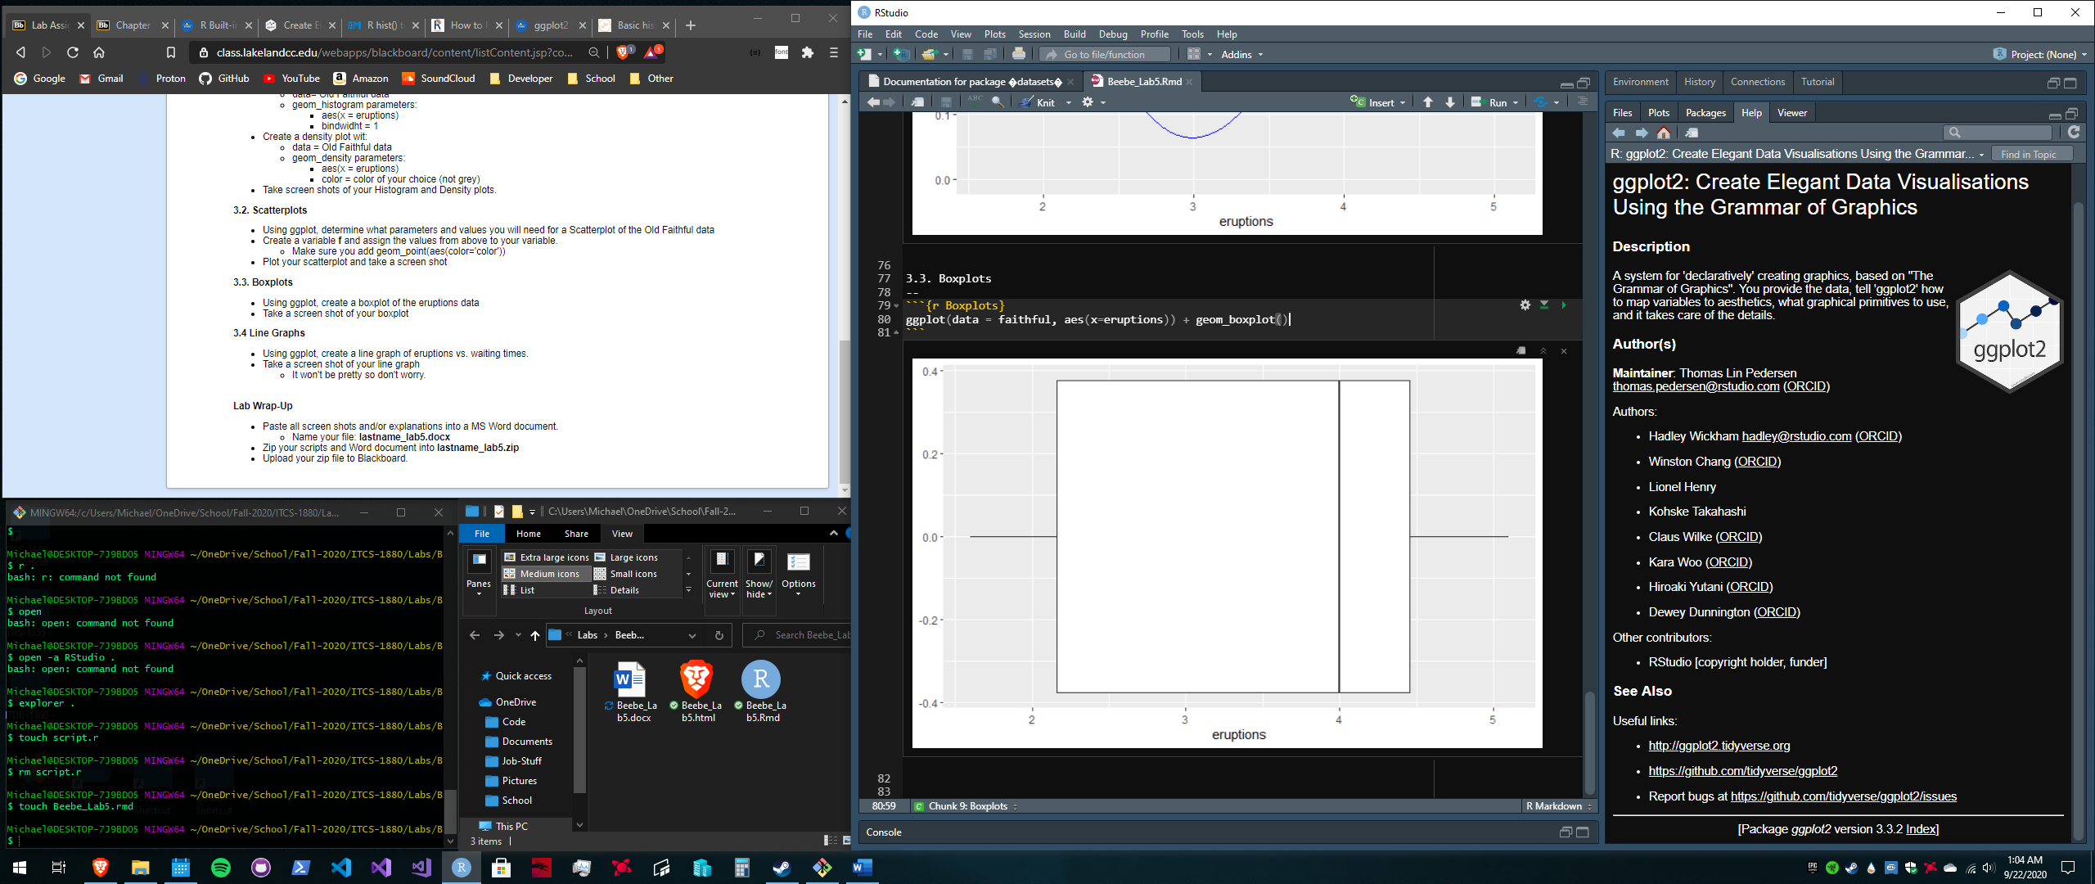

**3.4 Line Graphs**

